

MALTEPE UNIVERSITY FACULTY OF
ENGINEERING AND NATURAL SCIENCE

CEN 432 01 Itroductıon to Robotics

Midterm Project Report

Project Name:
Smart Autonomous Patrol System

Asude Salık -230704026
Pelin Tetik-230706006

TABLE OF CONTENTS
1.Introduction .........................................................................................
1 1.1. Project Overview
1.2. Objective and Scope
2. System Architecture ........................................................................
2.1. Sense-Decide-Act Cycle
2.2. Hardware Configuration and I/O Mapping
3. Hardware Components .....................................................................
3.1. Processing Unit: Arduino Uno
3.2. Sensing Units (Ultrasonic, PIR, LDR)
3.3. Actuation Units (Servo Motor, Buzzer, LEDs)
4. Finite State Machine (FSM) Design ................................................
4.1. Identification of System States
4.2. Priority Handling and Decision Logic
4.3. State Transition Rules
5. System Implementation ....................................................................
5.1. Circuit Schematic (Tinkercad)
5.2. State Diagram (Visual Representation)

5.3.Software Implementation Logic:
6. Experimental Results and Testing ...................................................
6.1. Simulation Scenario Testing
6.2. Priority Conflict Resolution
7. Conclusion ..........................................................................................
8. References ..........................................................................................
9.Ful Source of Code with Commends...................................................

1. Introduction:
1.1. Project Overview
This project involves the design and implementation of an Autonomous Security Patrol System using the Arduino Uno microcontroller. The system is designed to monitor its surroundings in real-time, utilizing a multi-sensor array to detect physical obstacles, human motion, and environmental light conditions. Unlike basic reactive systems, this project implements a complex decision-making framework that allows the system to evaluate its environment and transition between distinct operational modes dynamically.

1.2. Objective and Scope
The primary objective of this project is to demonstrate the integration of hardware and software through the "Sense-Decide-Act" paradigm. The project aims to fulfill the following goals:

- Multi-Sensor Fusion: Integrating Ultrasonic, PIR, and LDR sensors to gather comprehensive environmental data.

- State-Based Control: Implementing a Finite State Machine (FSM) to manage system behavior, ensuring that the robot reacts appropriately to conflicting stimuli.

- Autonomous Navigation: Enabling the system to perform routine patrols while maintaining the ability to avoid obstacles and trigger security protocols without human intervention.

- Prioritized Logic: Establishing a hierarchy of decisions where safety and security alerts (Intruder Detection) take precedence over routine operations (Patrol/Night Mode).

2. System Architecture:
2.1. Sense-Decide-Act Cycle The operational framework of the Smart Autonomous Patrol System is based on a continuous loop consisting of three fundamental stages:
Sense: The system continuously gathers environmental data through the multi-sensor array (Ultrasonic, PIR, and LDR). Each sensor monitors a specific physical variable: distance, infrared radiation (motion), and light intensity.
Decide: This is the core stage where the Finite State Machine (FSM) processes the raw input data. Based on the predefined conditions, the system evaluates which "State" it should be in. Crucially, this stage handles
Priority Logic : if multiple sensors trigger simultaneously, the decision-making unit selects the state with the highest importance (e.g., security over navigation).
Act: Once a decision is made, the system updates its behavior by controlling the actuators. The Servo motor, Buzzer, and LEDs change their status to reflect the current state (e.g., turning the motor or activating the alarm).

2.2. Hardware Configuration and I/O Mapping
To ensure stable performance and precise timing, the hardware is configured to utilize specific digital and analog pins of the Arduino Uno. This mapping ensures that high-priority interrupts (like motion detection) and PWM signals (for the servo) do not conflict.

3. Hardware Components:
This section details the hardware selection for the Smart Autonomous Patrol System. Each component was chosen to fulfill the specific requirements of monitoring, decision-making, and responding to environmental stimuli.
3.1. Processing Unit
- Arduino Uno: Serving as the central processing unit (CPU), it executes the FSM logic, reads analog/digital inputs from sensors, and generates PWM signals for the actuators.

3.2. Sensing Units (Inputs) These components allow the system to "Sense" its environment:
- Ultrasonic Sensor (HC-SR04): Used for Obstacle Detection. It measures the time-of-flight of sound waves to calculate the distance to the nearest object.

- PIR Motion Sensor: Responsible for Intruder Detection. It detects changes in infrared radiation to identify human movement.

- LDR (Light Dependent Resistor): Monitors environmental light intensity to trigger Night Mode when illumination falls below a specific threshold.

3.3. Actuation Units (Outputs)
These components allow the system to "Act" based on its decisions:
- Micro Servo Motor: Representing the locomotion and steering. It adjusts its angle to simulate "changing direction" during obstacle avoidance.

- Piezo Buzzer: Provides an audible alarm during the Intruder Alert state.

- LED Indicators (Red LED): Visual warning for security breaches (Intruder Alert).
Yellow LED: Status indicator for Night Mode operations.

Component | Technical Role | State Triggered
HC-SR04 | Proximity Sensing | Obstacle Avoidance
PIR Sensor | Passive Infrared Detection | Intruder Alert
LDR | Illumination Sensing | Night Mode
Servo | Directional Control | All States

4. Finite State Machine (FSM) Design:
This section describes the logical brain of the system. The patrol unit does not merely react to sensors; it operates within a Finite State Machine (FSM) framework to manage complex environmental conditions and prioritize safety .

4.1. Identification of System States
The system is designed with four distinct operational modes :
- Patrol Mode: The default state where the system moves forward or remains idle, monitoring all sensors .
- Obstacle Avoidance: Triggered when the ultrasonic sensor detects an object within 20cm. The system changes direction to prevent a collision .
- Intruder Alert: A high-priority state triggered by motion. The system stops and activates visual (LED) and audible (Buzzer) alarms .
- Night Mode: Triggered in low-light conditions. The system activates auxiliary lighting and may adjust its sensitivity .

4.2. Priority Handling and Decision Logic To prevent logical conflicts (e.g., if both an obstacle and an intruder are detected simultaneously), a strict priority hierarchy is implemented:
- Priority 1 (Highest): Intruder Alert (Security is the ultimate goal).
- Priority 2: Obstacle Avoidance (Physical integrity of the robot).
- Priority 3: Night Mode (Environmental adjustment).
- Priority 4: Patrol Mode (Default routine).

4.3. State Transition Rules Transitions occur based on conditional logic. If the high-priority condition (Motion) is met, the system bypasses lower states and enters the "Alert" state immediately. Once the condition is cleared (e.g., motion stops), the system reverts to its default "Patrol" state.

5. System Implementation:
5.1. Circuit Schematic (Tinkercad) The system was designed and simulated on the Tinkercad platform to ensure electrical stability and logical correctness. The Arduino Uno acts as the central hub, with the following wiring strategy:
- Power Rails: A common 5V and GND rail power the three sensors and the servo motor.
- Signal Integrity: Digital pins are used for the PIR sensor and the Ultrasonic Trigger/Echo, while the LDR is connected to an Analog pin to read varying light intensities.
- Actuator Control: The Servo motor is connected to a PWM-enabled pin (Pin 10) to allow precise angular positioning.

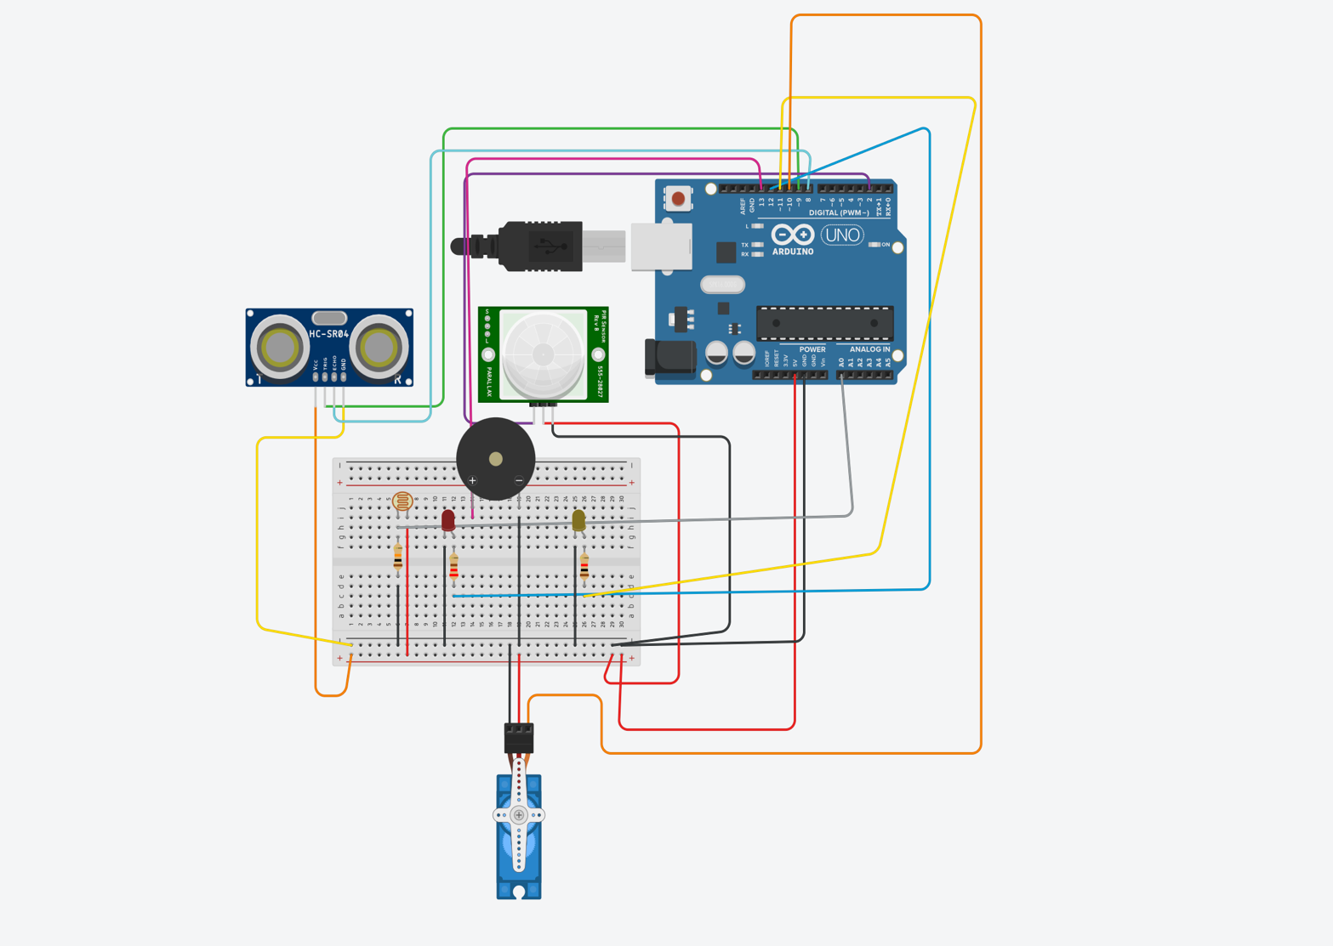

Figure 1: Tinkercad simulation circuit layout
5.2. State Diagram (Visual Representation) The following diagram illustrates the logical flow of the system. It visualizes how the robot transitions between states based on environmental triggers and priority rules. This diagram is the graphical representation of the code's decision-making architecture.

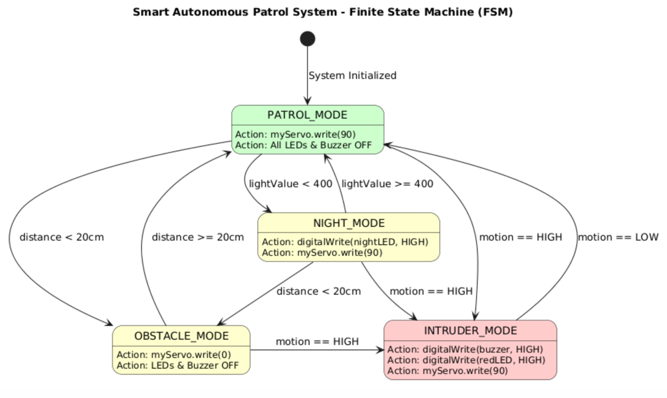
Figure 2: Finite State Machine (FSM) Diagram

5.3.Software Implementation Logic:
The software is developed using a State-Based Architecture. Instead of using a simple linear flow, the program is structured around a central decision-making unit that updates the currentState variable based on sensor priorities.
- Logic Structure: The system uses an if-else if hierarchy to handle Priority Logic, ensuring that "Intruder Alert" conditions always override "Patrol" or "Obstacle" modes .

- Modular Functions: Independent functions like readDistance() and applyBehavior() are used to keep the code clean, readable, and maintainable.

Note: The full source code with detailed line-by-line comments can be found in Section 9.

6. Experimental Results and Testing:
6.1. Simulation Scenario Testing The system was tested under four primary scenarios to verify its decision-making capability:
- Scenario A (Normal Operation): No movement or obstacles detected. System remained in Patrol Mode (Servo moving, LEDs OFF).
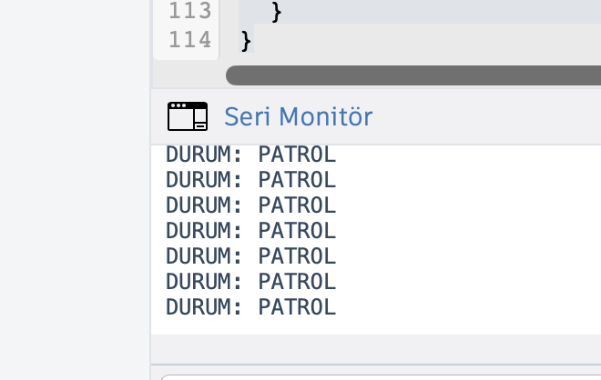
- Scenario B (Obstacle Encounter): Distance dropped below 20cm while in Patrol. System immediately switched to Obstacle Avoidance and changed servo direction
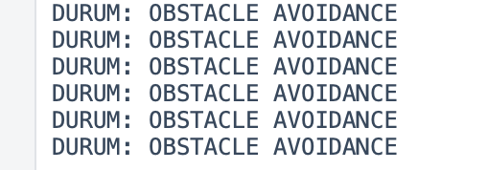

- Scenario C (Security Breach): Motion detected by PIR. System switched to Intruder Alert, activating the Buzzer and Red LED, overriding all other states .
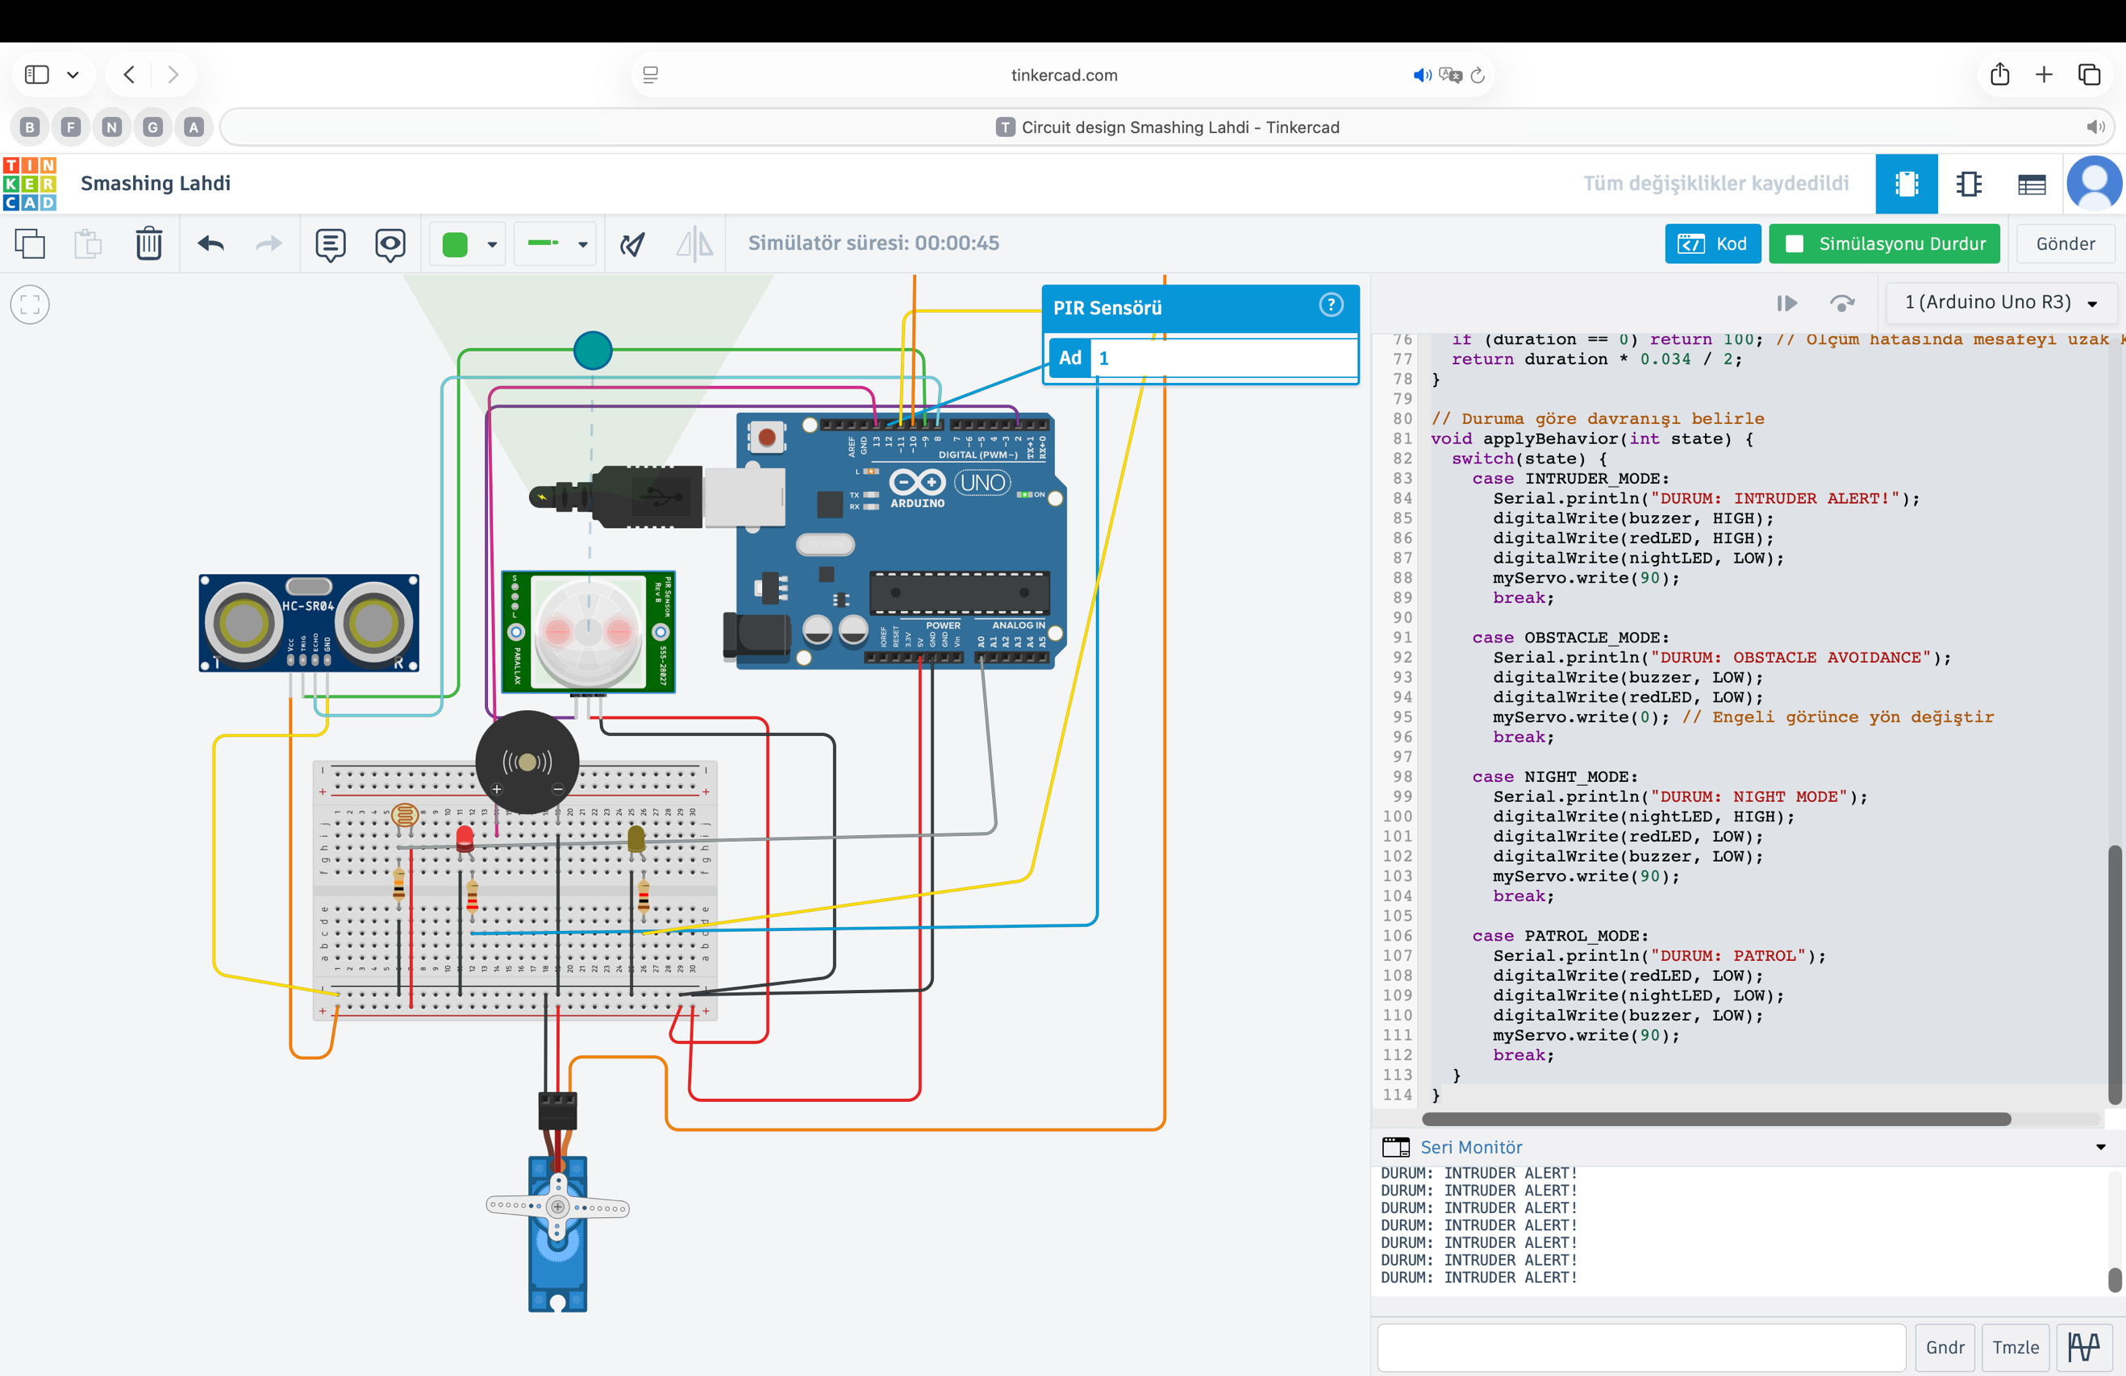

- Scenario D (Low Light): Light level dropped below the threshold. System activated Night Mode while continuing to monitor for intruders .
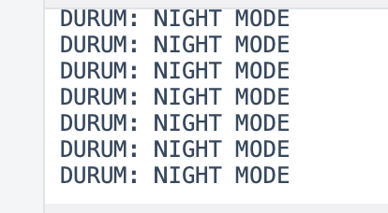

6.2. Priority Conflict Resolution A critical test was performed by triggering both "Obstacle" and "Intruder" sensors simultaneously. As expected, the system prioritized the Intruder Alert, proving that the Priority Handling logic works as intended.

7. Conclusion:
The "Smart Autonomous Patrol System" successfully demonstrates the integration of a Finite State Machine (FSM) with a multi-sensor array to create a prioritized decision-making environment. By following the "Sense-Decide-Act"paradigm, the system has moved beyond simple reactive behavior and achieved dynamic behavioral changes.
Key takeaways from this project include:
- Successful Priority Management: The system correctly prioritizes security (Intruder Alert) over navigation (Obstacle Avoidance), fulfilling the core requirement of the project.
- Autonomous Reliability: The use of distinct states ensures that the robot behaves predictably and safely under various environmental conditions.

- Scalability: The modular design of the FSM allows for the easy addition of more sensors or states in future iterations.
In conclusion, this project serves as a practical application of embedded systems logic and prioritized decision-making, meeting all technical requirements set forth in the project guidelines.

8. References:
- Tinkercad Circuits Documentation: Simulation environment for Arduino Uno, sensor integration (HC-SR04, PIR, LDR), and virtual prototyping.
- Arduino Reference Library: Documentation for Servo.h library, pulseIn() function, and standard I/O communication protocols. https://www.arduino.cc/reference/en/
- Course Project Guidelines: "PROJECT 1 – Smart Autonomous Patrol System", Task Description and Decision-Making Criteria, 2026.
- Finite State Machine (FSM) Design for Embedded Systems: Theory of state-based control logic and priority-driven transitions in autonomous robotics.
- C++ Programming for Arduino: Implementation of modular functions, switch-case structures, and if-else if priority hierarchies in embedded C++.

9. Full Source Code with Commends:

#include <Servo.h>

// --- PIN DEFINITIONS ---

const int trigPin = 9;

const int echoPin = 8;

const int pirPin = 2;

const int ldrPin = A0;

const int buzzer = 13;

const int redLED = 12;

const int nightLED = 11;

Servo myServo;

// --- SYSTEM STATES (FSM) ---

// Using integer constants for state definitions to ensure compatibility

const int PATROL_MODE = 0;

const int OBSTACLE_MODE = 1;

const int INTRUDER_MODE = 2;

const int NIGHT_MODE = 3;

int currentState = PATROL_MODE;

// --- FUNCTION PROTOTYPES ---

// Forward declarations for simulation environment compatibility

long readDistance();

void applyBehavior(int state);

void setup() {

pinMode(trigPin, OUTPUT);

pinMode(echoPin, INPUT);

pinMode(pirPin, INPUT);

pinMode(buzzer, OUTPUT);

pinMode(redLED, OUTPUT);

pinMode(nightLED, OUTPUT);

myServo.attach(10);

myServo.write(90); // Initial position

Serial.begin(9600); // Initialize serial communication

}

void loop() {

// 1. SENSE: Gather data from the multi-sensor array

long distance = readDistance();

int motion = digitalRead(pirPin);

int lightValue = analogRead(ldrPin);

// 2. DECIDE: Priority-based Logic (Intruder > Obstacle > Night > Patrol)

if (motion == HIGH) {

currentState = INTRUDER_MODE;

}

else if (distance > 0 && distance < 20) {

currentState = OBSTACLE_MODE;

}

else if (lightValue < 400) {

currentState = NIGHT_MODE;

}

else {

currentState = PATROL_MODE;

}

// 3. ACT: Execute behavior based on the current state

applyBehavior(currentState);

delay(100); // Small delay for system stability

}

// Function to measure distance using the Ultrasonic sensor

long readDistance() {

digitalWrite(trigPin, LOW);

delayMicroseconds(2);

digitalWrite(trigPin, HIGH);

delayMicroseconds(10);

digitalWrite(trigPin, LOW);

long duration = pulseIn(echoPin, HIGH);

if (duration == 0) return 100; // Assume path is clear in case of measurement error

return duration * 0.034 / 2;

}

// Function to update actuator behavior based on the FSM state

void applyBehavior(int state) {

switch(state) {

case INTRUDER_MODE:

Serial.println("STATE: INTRUDER ALERT!");

digitalWrite(buzzer, HIGH);

digitalWrite(redLED, HIGH);

digitalWrite(nightLED, LOW);

myServo.write(90);

break;

case OBSTACLE_MODE:

Serial.println("STATE: OBSTACLE AVOIDANCE");

digitalWrite(buzzer, LOW);

digitalWrite(redLED, LOW);

myServo.write(0); // Change direction when obstacle is detected

break;

case NIGHT_MODE:

Serial.println("STATE: NIGHT MODE");

digitalWrite(nightLED, HIGH);

digitalWrite(redLED, LOW);

digitalWrite(buzzer, LOW);

myServo.write(90);

break;

case PATROL_MODE:

Serial.println("STATE: PATROL");

digitalWrite(redLED, LOW);

digitalWrite(nightLED, LOW);

digitalWrite(buzzer, LOW);

myServo.write(90);

break;

}

}

.

